Ex. No: 1 SQL DML COMMANDS

**Date: 06/01/22**

**AIM:** To write SQL queries to execute different DML commands.

Data base created for this exercise is:

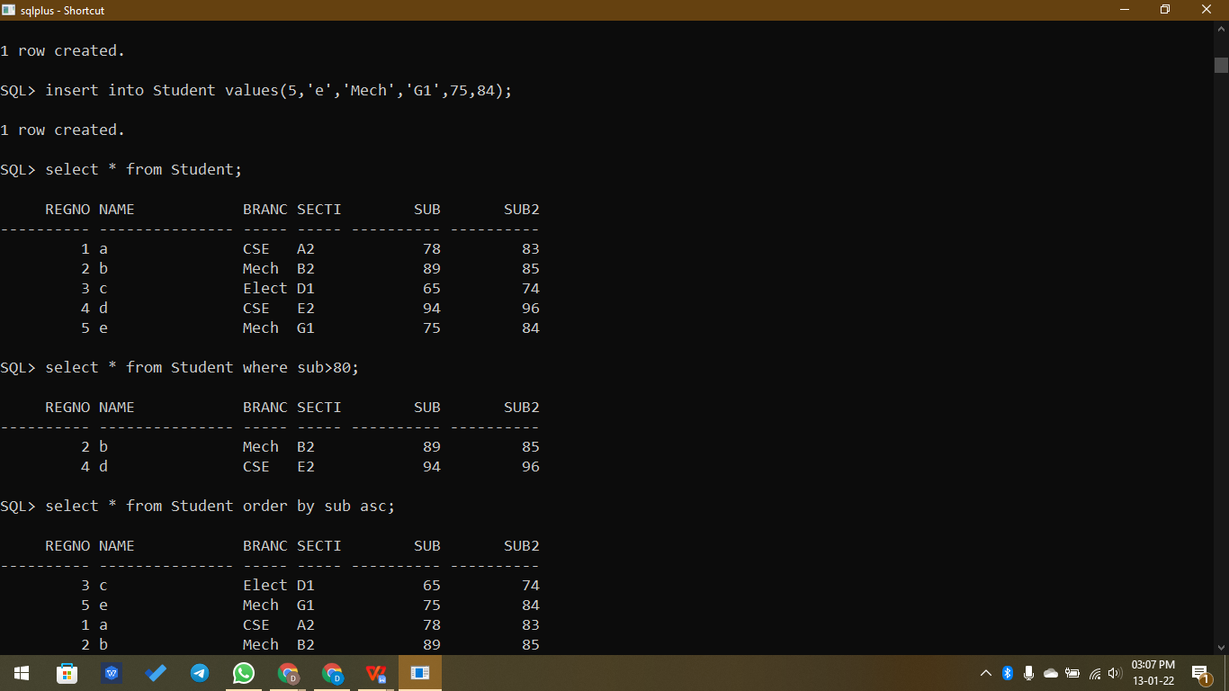

**DML Commands:**

* **Insert -** Used to insert records in the table

**Syntax,**

**INSERT into table_name values(value1, value2, …);**

Example,

SQL> insert into student values(1,'a',96);

1 row created.

* **Update -** Used to update existing data in the table

**Syntax,**

**UPDATE table_name set column1=value1;**

**UPDATE table_name set column1=value1 WHERE condition;**

Example,

SQL> update student set sub=sub-10;

5 rows updated.

* **Delete -** Used to delete records in the table

**Syntax,**

**DELETE from student WHERE condition;**

Example,

SQL> delete from student where regno=4;

1 row deleted.

SQL> create table student(regno int, name varchar(15), branch varchar(5), section varchar(5), sub int, sub2 int);

create table student(regno int, name varchar(15), branch varchar(5), section varchar(5), sub int, sub2 int)

*

ERROR at line 1:

ORA-00955: name is already used by an existing object

SQL> drop table student;

Table dropped.

SQL> create table student(regno int, name varchar(15), branch varchar(5), section varchar(5), sub int, sub2 int);

Table created.

SQL> insert into student values(1,'a','CSE','A2',78,83);

1 row created.

SQL> insert into Student values(2,'b','Mech','B2',89,85);

1 row created.

SQL> insert into Student values(3,'c','Elect','D1',65,74);

1 row created.

SQL> insert into Student values(4,'d','CSE','E2',94,96);

1 row created.

SQL> insert into Student values(5,'e','Mech','G1',75,84);

1 row created.

SQL> select * from Student;

REGNO NAME BRANC SECTI SUB SUB2

---------- --------------- ----- ----- ---------- ----------

1 a CSE A2 78 83

2 b Mech B2 89 85

3 c Elect D1 65 74

4 d CSE E2 94 96

5 e Mech G1 75 84

SQL> select * from Student where sub>80;

REGNO NAME BRANC SECTI SUB SUB2

---------- --------------- ----- ----- ---------- ----------

2 b Mech B2 89 85

4 d CSE E2 94 96

SQL> select * from Student order by sub asc;

REGNO NAME BRANC SECTI SUB SUB2

---------- --------------- ----- ----- ---------- ----------

3 c Elect D1 65 74

5 e Mech G1 75 84

1 a CSE A2 78 83

2 b Mech B2 89 85

4 d CSE E2 94 96

SQL> select sum(sub) from Student group by branch;

SUM(SUB)

----------

164

172

65

SQL> update student set sub=sub-10;

5 rows updated.

SQL> select * from student;

REGNO NAME BRANC SECTI SUB SUB2

---------- --------------- ----- ----- ---------- ----------

1 a CSE A2 68 83

2 b Mech B2 79 85

3 c Elect D1 55 74

4 d CSE E2 84 96

5 e Mech G1 65 84

SQL> delete from student where regno=4;

1 row deleted.

SQL> select * from student;

REGNO NAME BRANC SECTI SUB SUB2

---------- --------------- ----- ----- ---------- ----------

1 a CSE A2 68 83

2 b Mech B2 79 85

3 c Elect D1 55 74

5 e Mech G1 65 84

SQL> spool off

**Result:**

Thus the DML commands are used to modify or manipulate data records present in the customer database tables.